# **ZOMATO REVIEW SYSTEM**

**The Analysts:**

**Guides**:

Deepika and Nidhi Ma’am,

Prashanth Sir

Naman.V

Kalyan.J

Keerthan.K

Haswanth.V

1.1-INTRODUCTION

AI:

Artificial intelligence is the intelligence demonstrated by machines, instead to the intelligence displayed by humans.

Python:

Python can be used alongside software to create workflows.

Python is a high-level, interpreted, interactive and object-oriented scripting language. A major advantage for using Python for AI is that it comes with inbuilt libraries. Python has libraries for almost all kinds of AI projects. For example, NumPy, SciPy, matplotlib,nltk, SimpleAI are some the important inbuilt libraries of Python.

1.2 Objectives of Research:

* Helping people discover great places around them
* Building amazing experiences around dinning
* Enabling restaurants to create amazing experiences.

1.3 Problem statement

A restaurant’s rating Zomato didn’t make or break it is business back then. Nowadays it does make a difference to a certain extent.

The main objective of our project is to classify the customers review into Positive, Negative and neutral

2.Review of literature

* Zomato Restaurants Data - Analyzing the best restaurants of the major cities by Shruti Mehata
* Zomato Base REVIEW- Restaurant Management Software

3. Data Collection

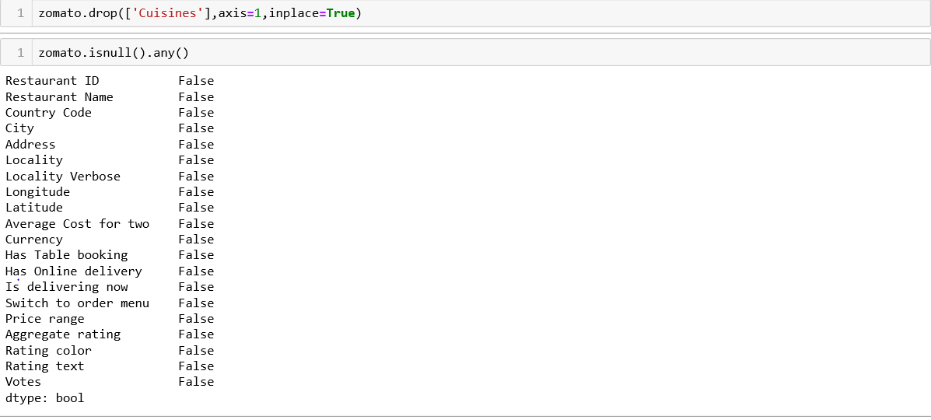

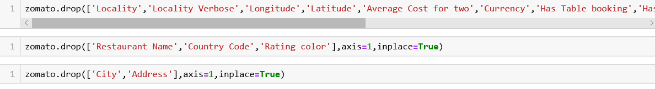

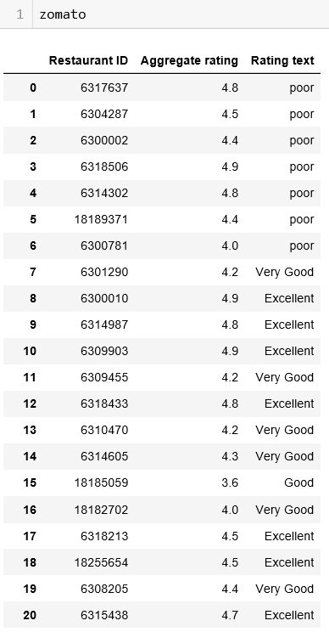

4.Methodology

4.1Exploratory Data Analysis

4.1.1Figures and Tables

Table 1&2 : pre-processed data

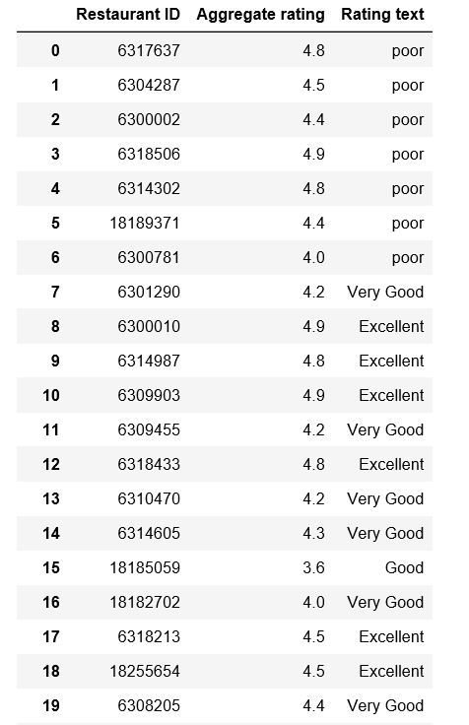 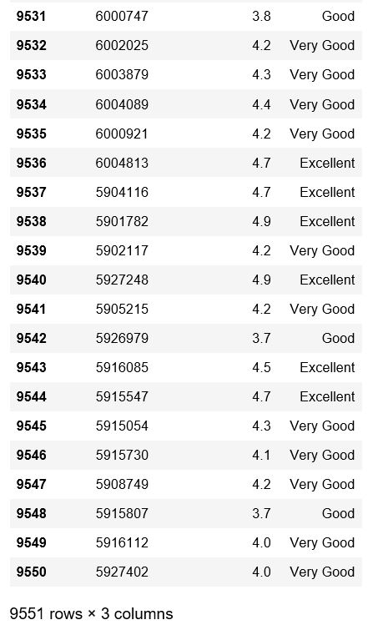

Table 4&5 : based on rating text using Sentimental Analysis given text review score

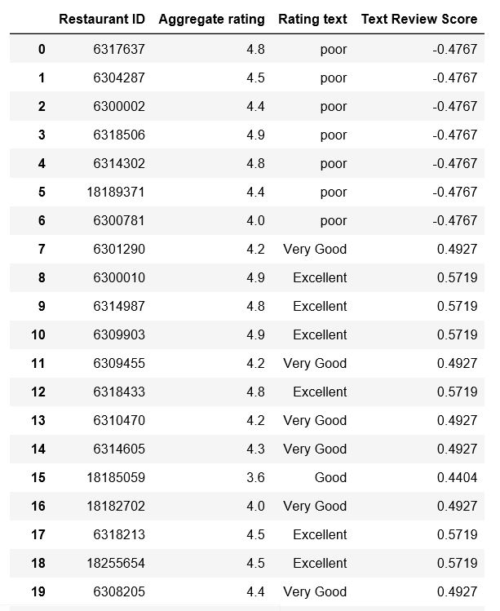

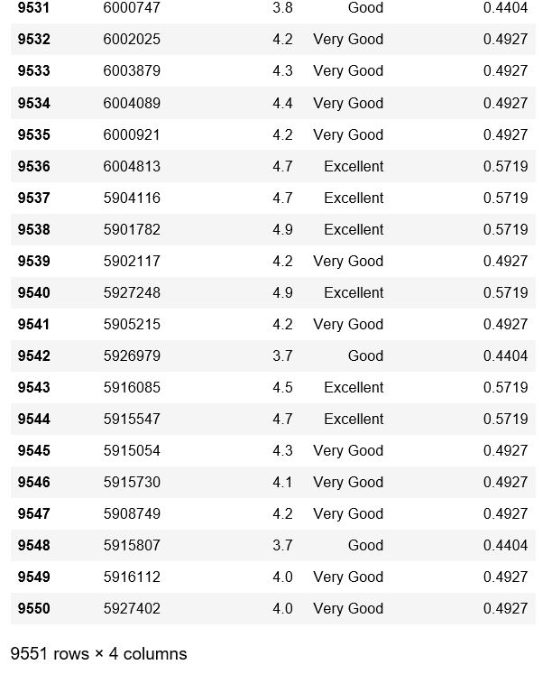

Table 5&6 : based on Aggregating rating using Sentimental Analysis given Rating Sentiment LAbel

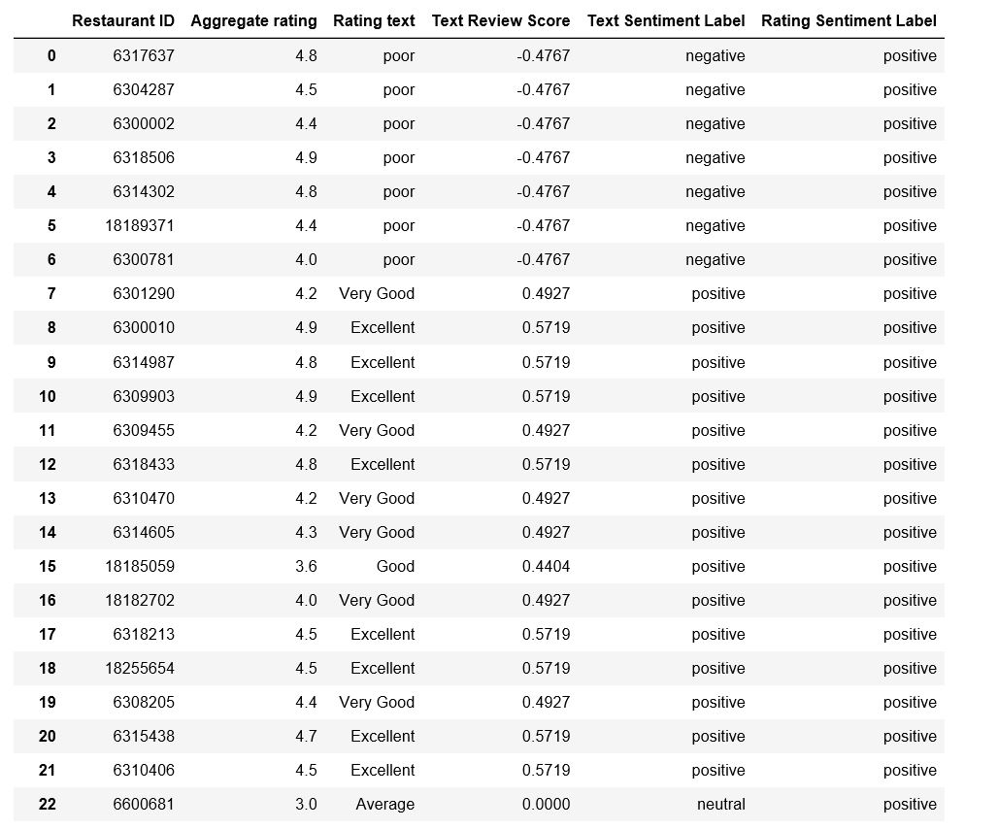

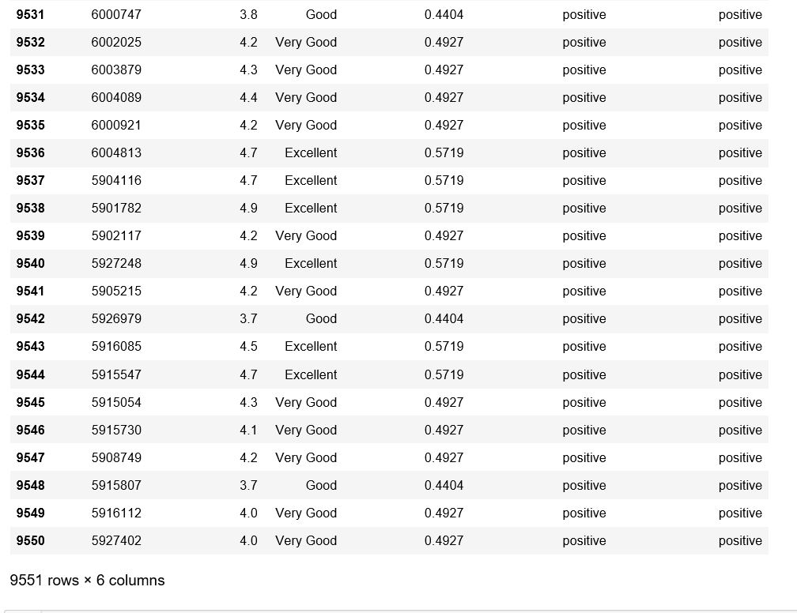

4.2 Data Modelling

Sentimental Analysis

It’s the process of Analyzing online pieces of writing to determine the emotional tone they carry.

Sentiment analysis and opinion mining finds broad application ranging from e-commerce, marketing, to politics and research

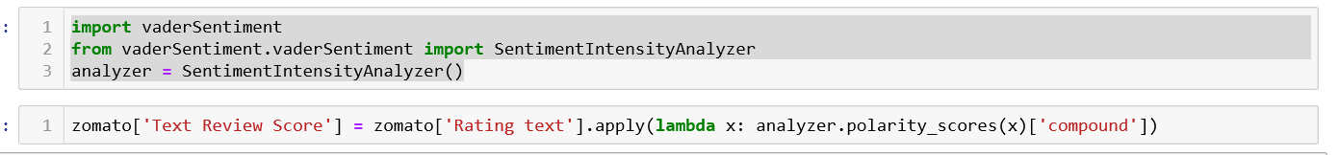

 

5.Findings and Suggestion

The model that we have built till now can only predict whether a comment is positive or neutral or negative. But it would be great if the model has the capability of filtering spam comments

6.Conclusion

A look into venture in information mining

which includes the investigation of the subject,

information mining methods, information mining

forms, information mining calculations and its usage

bitterly to make it more intelligent to the clients.

Presenting the crude information subsequent to

preparing and executing the information mining

procedures in intuitive way to the clients for better

understanding. Implementing the systems of content

mining to examine the content audits from the client

with a specific end goal to produce productive result

and legitimate surveys. Collecting client surveys

database and handling it to check the honesty of the

rating given and audit composed. Calculating value of

the eatery in the wake of breaking down the audits as

indicated by the administration and cost estimation!